Assignment 2F: Final Report
Grant Brownfield
ECT 375: Advanced Digital Animation & HCI Technology
Professor Jared Wuerzburger
March 28, 2026

FERM FRESH KOMBUCHA: Website 2.0
Proposed by Grant Brownfield
Grant Brownfield is a Student at ISU. This project was done in partnership with Ferm Fresh Kombucha with Anthony and Meghan Gossett.
Problem and Solution Overview
For Ferm Fresh, I want to create a website, as well as potentially a way to make to-go orders. When looking for businesses, I primarily wanted to indulge in making a website, since I enjoyed doing it back in high school when we did web programming my junior year for a few weeks, and have more experience with it thanks to CS 170. Ferm Fresh is a great candidate for this, as their website I tried contacting them at bugged out and didn’t send my email asking for help signing the business agreement, and I had to come in and talk to them about it after creating a Facebook account and messaging them on there. That, and my mom knows the owners, so there’s less risk there.
When I talked to them, they said that the website would be handy, as their current website has photos from when their location was in 12 Points, as well as the fact that they were having trouble accessing the website. The new website would feature updated pictures, their address, hours, menu, and what flavors they have. On top of this, the owners of Ferm Fresh, Anthony and Megan, would be able to update the flavors and hours as they needed. They had no suggestions for style choices other than the core points mentioned above and the pictures.
Additionally, I want to potentially add the feature to order drinks to-go. While the website is the main priority, being able to order cups, glasses, or jugs to-go and have them already paid would be handy. It would make the website more practical and potentially attract more customers.
While discussing this, I gave the forewarning that this is the first time doing a project like this, and there is a chance that the project may not work. However, there would be no costs associated, and I’d be willing to send the code and information once the project is finished for the owners to use. I still must figure out posting the website to a database, and how to explain it to them considering they said they weren’t very tech savvy.

Design Research Goals, Stakeholders, and Participants
Users & Potential Users
My app is for Ferm Fresh, and is meant to be simple and accessible for people of all ages. Having a website that is simple to access, read, and gather information from. My users are pretty much any local of Terre Haute, any gender, any age, any race. I will aim for a variety of genders and races conducting this interview, but will mainly try for someone young (Gen Z), someone middle aged (Millennial – Gen X), and someone older.
Research Methods
For this project, I will primarily be performing user interviews, or one-on-one interviews, same as the last semester. When I’m interviewing people, I will ask them if they know what Ferm Fresh is. If they don’t, I’ll show them the website, the place, and what they think would work best for a website of said place. If they do, I’ll simply ask them what should be added or included in the website. I might also ask what kind of website they would imagine they have.
I could also use focus groups if I had the proper people and resources available. This would be good to brainstorm new ideas for the website, but not so much errors/what needs improved.
On-Line surveys would be great too. It can have instructions on how to website and what pages to look at, a box to enter what the user likes about the website, and a box to enter what the user dislikes about the website. This could be easy to share around; however, it would be difficult to compile all the results up as there’s no “concrete” answer people can give. If the questions were different (i.e. “on a scale of 1-10") it would be more useful.
So, I think I will be sticking to one-on-one interviews. It’s the easiest way to get the most detailed information, and it allows me to pick out who to interview to get the most varied results. For my interviews, I did one with my clubmate, my mother, and my grandmother.

Design Research Results and Themes
Across the interviews, the answers to these questions had lots of overlap. I think the most common themes were fixing the formatting to flow better/be easier to read, and adding more concrete information. Adding information about the kombucha too, whether it be where they were hosting events, how many gallons are in a keg, what flavors there are, when said flavors update, and how to volunteer were big things as well.
Interview with Becky Rogers (Grandma)
Becky Rogers is my grandma, who assisted in the last interview I did for 275. She is 75 (76 in a few months!), knows Ferm Fresh, and has been a few times. However, she is not very apt with technology, but knows the basics. I picked her out as she fits the “older” age range, and knows Ferm Fresh, so she would make any problems with navigating or using the website obvious.
My interview with her went well, I simply had her navigate and read through the tabs on the website (https://fermfreshkombucha.com/). She was generally pleased with the website, aside from a few things. First, the “About” page was messy, which seems to be a common theme across interviews. Second, on the “Partner” page the website doesn’t display the number of gallons per keg, which may be important to those wanting to purchase a keg or kegerator. Third, she wished that the business partners had addresses to go along with them so that you wouldn’t need to look them up individually. Finally, she said that the theme of the website was good, but the font could maybe be changed. Overall, she enjoyed looking through the website and reading about it, aside from the little things mentioned above.
Interview with Christina Evans (Mother)
Christina Evans is my mother, and I interviewed her for the project last semester as well. She is a regular of Ferm Fresh, friends with the owners, and almost always has a jug of Kombucha in the fridge. Mom fits the “middle-aged” group, knows how to use technology, and knows the owners, so she might be able to point out things that are missing or that Anthony and Megan might want.
Her interview was the same as nana’s: going through the website and pointing out flaws. One thing she mentioned was that the “About” page should have a date written, as “9 years ago” and other non-concrete dates are out of date now. She also suggested that the pictures be updated to match the current location, and that the font and headers be updated to be easier to read, at least on mobile.
As for things that can be added, Christina suggested that there be a weekly Kombucha fact, taken from the web or a database. This can keep the website interesting and have people learn more about kombucha, where it comes from, and why they should buy a drink from Ferm Fresh. She also suggested that we add a tab for upcoming events that Ferm Fresh might be attending, and a way to sign up to help volunteer. This last suggestion she said to add caution, as things with insurance or business policies may interfere with volunteering. With that though, she was able to add a lot to fix and to add when making this website.
Interview with Anonymous (Younger College Student)
The first person I interviewed was a clubmate in the cosplay club. He is roughly the same age as me, did not know about Ferm Fresh, and is not from Terre Haute, but still goes to ISU. He had a lot of criticism about the website, especially formatting. I’ve taken bullet points below as notes.
Looking at the websites, we started going off of the second one after I realized that there were two websites. The second one was updated to have more tabs and be an overall better reading experience, but still had flaws. Most of the errors were formatting especially with a page of white space at the bottom of the page. However, the interviewee enjoyed the pictures and thought that they were a great addition. On that topic, however, they made some text or logos hard to read. For the menu, he suggested that we add a statement about the flavors changing weekly.
Other than that, he thought it was a solid website but could use some improvements. I also told him to visit when they have a chance.

Answers to Task Analysis Questions
Task 1: Learn what Ferm Fresh is
A lot of participants I talked to had no idea what Ferm Fresh even was until I pulled up the website. This task is already done with the current website but could be improved. This includes fixing punctuation/grammar, making the font easier to read, fixing the headings, updating the pictures, and updating the dates, and even adding things like weekly updating kombucha facts.
Task 2: Get directions to Ferm Fresh
Now, they’re interested in Ferm Fresh, but don’t know where to go. They look at the website for directions and hours. There isn’t much to this, other than some text and maybe a link to it on google maps.
Task 3: Get information on Partnered Business
When my grandma was navigating the website and got to the business tab, she stated that she wanted to see the locations to the businesses that were partnered with Ferm Fresh. You could do this by searching for them on google, but that was a pain to do. Having a link to the website and its address could help customers find other businesses that have Kombucha would further benefit Ferm Fresh as well as the other businesses that buy from them.
Task 4: View Menu and see Flavors & Items
The menu tab only has the items and prices. There is no way to find out about flavors or how they work (that being, they update every week). Updating the menu to be able to view flavors that are available or saying that the flavors update weekly would be good.
Task 5: Order kegs, events, and have volunteers
Though this one might not be used as much, being able to see how much kombucha is in a keg and way to order them on the website would be beneficial to the other businesses that use Ferm Fresh, as well as ones that are potentially interested in them. This also includes scheduling events, and, depending on the event. If needed, there could be a way of potentially having volunteers to assist with events, and people can sign up by calling or using a volunteer form on the website. However, there may be legal issues regarding volunteering that I would need to research and talk to Ferm Fresh about.
Task 6: Order Drinks to-go
Finally, the big one we talked about: the ability to order drinks and other items to-go. On top of all the other tasks (aside 3 and 5), this would be the final one to be accomplished. The customer knows of Ferm Fresh, where to go, and what to order. If I fail task 4, it will make this task much harder, as customers don’t know what flavors are available and will make ordering much less streamlined if they must call and ask. I bring this up here because the owners aren’t very technology apt and might have trouble updating the flavors by hand, unless a whole other interface or measures are done. A lot of the project will be trying to update the website to be able to do this task.

Proposed Design Sketches (3x4)
Design 1: Same Website, just Renovated
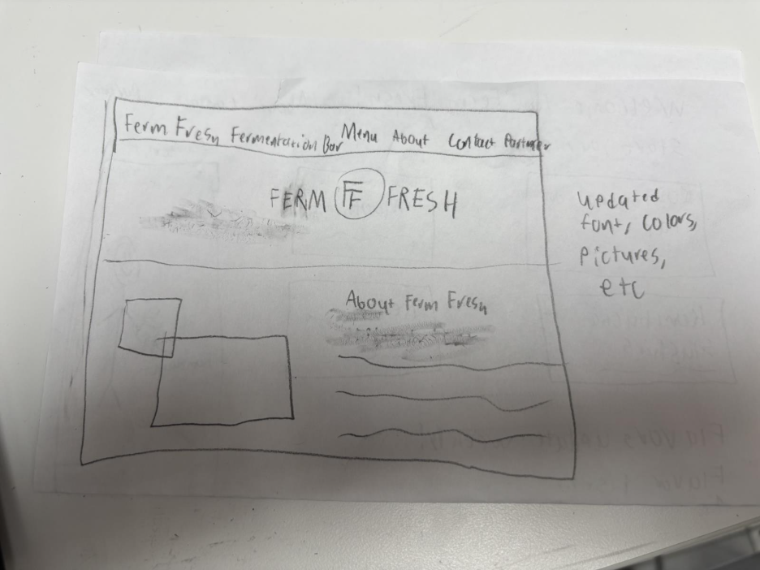 The idea of this is simple: Just update the website. One of the things that Anthony and Megan wanted me to do was update the website to show updated pictures, which could be done with this. It would also give me the opportunity to organize things better, eliminate white space, and change colors, fonts, etc., making it a simple but still functional website. It would accomplish Tasks 1-4, providing information about Ferm Fresh through the home page and “About” buttons, directions to Ferm Fresh, partners and where to find them on “Partners,” and the menu and items on the “Menu” tab. Task 5 could be included in the renovation, and task 6 could be included if we decide that we want to implement a way to order drinks to go.
Design 2: Location/Contact focus
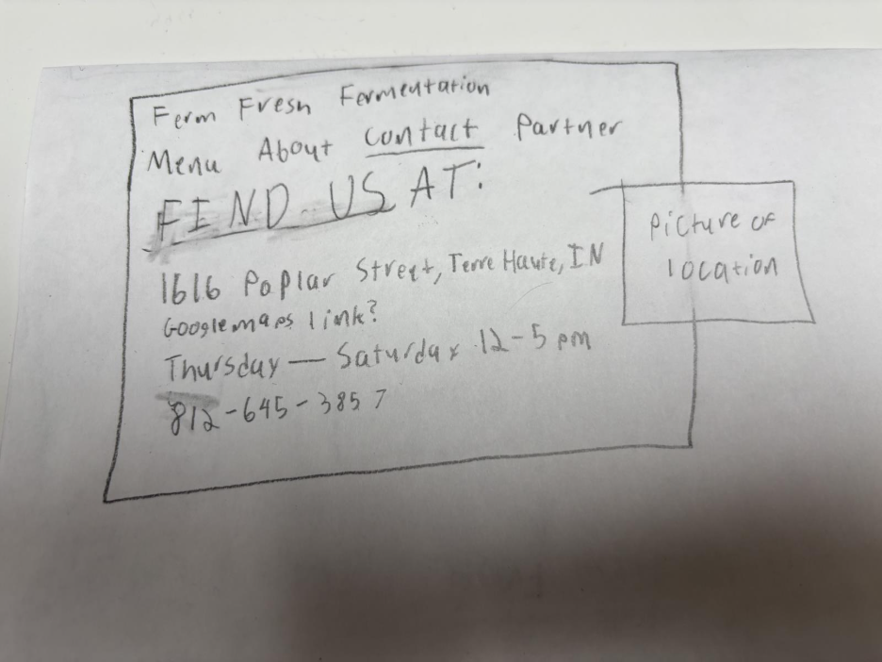 This design is the same idea as the first design, except the home page or starting page is where the restaurant is located. You can do everything that you can before, but the website has the phone number, address, etc. readily available if people are in a hurry and need the contact information right then and there. There is even a link to the location on google maps or whatever maps app the user uses for added ease of use. It accomplishes the same tasks as design 1, but with more of a focus on task 2 (Getting directions to Ferm Fresh) than task 1 and the other tasks.
Design 3: To-go menu focus
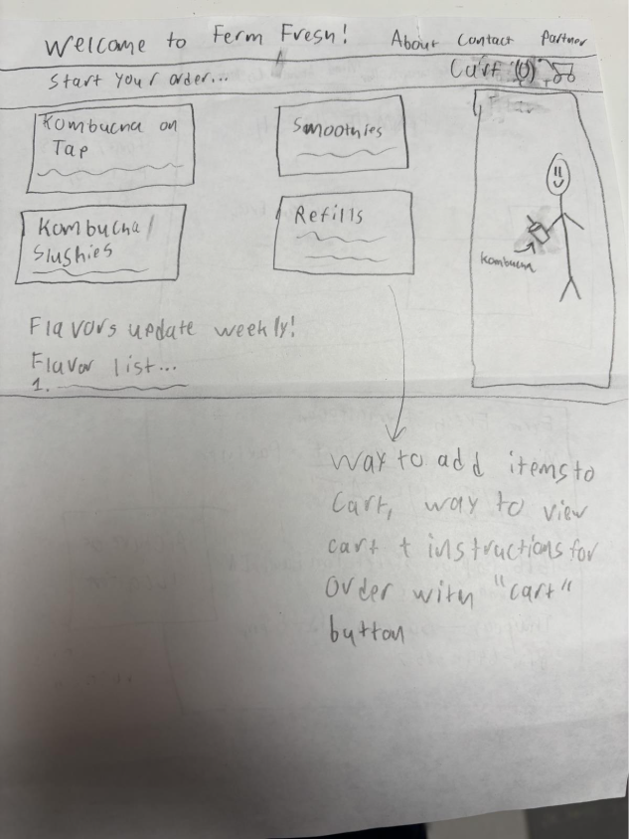
This design is mostly focused on adding the fact that you can order drinks and items to go on the website. It has a menu with items, all the available flavors, a way to view your cart, and the ability to use the other tabs (about, contact, business) as well. The rest of the website will still be updated, but focus will be primarily on getting this design to work. Although this design can perform all tasks, it is primarily focused on Task 1, Task 2, and Task 4, through the tabs on the top, and Task 6 by placing an order for drinks and flavors, as shown on the main pages.
Written Scenarios - “1x2”
For these scenarios, I have gone with the third interface, the To Go design. I chose this as it covers all six tasks, and can also cover renovating the website. If the to-go area doesn’t work, however, as there have been complaints of security using AI to build code, I will settle on design 1 of simply renovating the website and organizing it better.
Task 6: Ordering items to go (& task 4)
- User opens website.
- User sees what flavors are on the menu, and what items they want.
- User adds items to cart, adding flavors, sizes, etc.
- User selects cart and proceeds to payment.
- User inputs information, or sends the to go order to Ferm Fresh and choose to pay there.
- Order is finished.
Task 1 & 2: Learn what Ferm Fresh is and where it is
- User goes to website.
- User selects “About” at the top.
- User can read through the page, selecting hyperlinks that lead to related pages or even pages outside of the Ferm Fresh host.
- User is interested, they select “contact.”
- User gets address, and can click a link to view it on Google Maps.
Summary
I am building a Next.js/Supabase app for Ferm Fresh of Terre Haute. Here is the design context and the two primary tasks: Recreate the original Ferm Fresh Terre Haute Website (https://fermfreshkombucha.com/) and update it by eliminating white space, change colors, fonts, etc., making it a simple but still functional website. I need you to act as the Senior Developer for this project.

